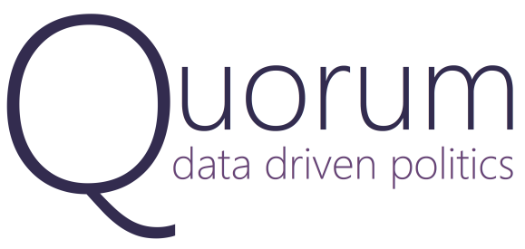
Media Contact
Al Ryan Thornton | Communications
ryan@quorum.us | 724-316-8930

Quorum Expands Legislative Strategy Platform to the State Level

WASHINGTON, DC, August 4th, 2015: Quorum today launched its next generation legislative strategy platform for the state level at the National Conference of State Legislatures, bringing the world's most comprehensive database of legislative information and powerful quantitative insights to all 50 states.
Quorum is an online legislative platform that helps legislative professionals, state legislators, and Members of Congress effortlessly track legislation and statements across all 50 states and the U.S. Congress, expand their legislative coalitions, and manage legislative strategies.
Quorum is the only platform that can algorithmically classify bills by over 1,000 different issue areas to provide actionable insights into each legislator's top issues; use data to identify with whom legislators work most frequently; conduct line-by-line bill text comparison; search across Facebook and Twitter posts; and map an array of Census Bureau demographic statistics over state legislative districts.
"Our addition of legislative and demographic data for all 50 state legislatures allows our users to track legislation, build support, and take action," said Alex Wirth, cofounder of Quorum. "Having a dad who serves in the New Mexico State Senate, I know firsthand the impact that our insights will have on how people engage with the legislative process."
Launched in January of 2015, Quorum's federal product has seen rapid adoption across Washington from some of the largest advocacy groups including Holland & Knight and the Glover Park Group, Fortune 100 companies like General Motors, as well as non-profits like the First Focus Campaign for Children, and a number of congressional offices.

In addition, Quorum's quantitative insights have been featured in over 30 media outlets such as The New York Times, Washington Post, CBS, MSNBC, the National Journal, and POLITICO.
"Quorum is an amazing and powerful tool exploring the intersection of elections and policy. Even the smartest and most experienced lobbyists will find that Quorum's fascinating data will help them understand and anticipate the behavior of legislators," said Charlie Cook, editor and publisher of The Cook Political Report.
Quorum allows legislative professionals to efficiently search through, save, comment on, and receive email alerts for all bills, votes, Tweets, Facebook posts, committees, and much more from the U.S. Congress and all 50 state legislatures.
"We built Quorum to put all of the information you need about Congress and the 50 state legislatures directly at your fingertips while also providing powerful quantitative insights and project management tools that will change the way you approach the legislative process," said Quorum cofounder and technical lead Jonathan Marks.
Legislative professionals can email states@quorum.us to see a demo of the new platform and talk with a member of the business development team.

###

About Quorum
Quorum is an online legislative strategy platform that provides legislative professionals access to the world’s most comprehensive database of legislative information, unique quantitative insights, and time saving productivity and collaboration tools that make it easier to track legislation, build support, and take action.

Called "The Moneyball Effect on K Street" by the Washington Post, Quorum has been featured in over 30 major news outlets and is used by numerous congressional offices and organizations like The Podesta Group, General Motors, Club for Growth, Holland and Knight, Toyota, and The United Nations Foundation.

More information including screenshots of Quorum can be found at www.quorum.us/features.

