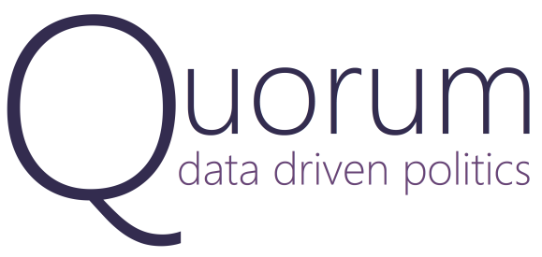
Media Contact
Al Ryan Thornton | Communications
ryan@quorum.us | 724-316-8930

Quorum Announces New Partnership With The Cook Political Report

WASHINGTON, DC, July 6th, 2015: Quorum today announced a new partnership with The Cook Political Report to provide valuable electoral and congressional data, bringing unparalleled insights to Quorum’s users and readers of The Cook Political Report.

“Charlie Cook has been an inspiration on what it means to be a political entrepreneur,” said Quorum cofounder Alex Wirth. “I first got to know Charlie at the Harvard Institute of Politics, where I was astounded by his incredible knowledge of our political system and the American electorate. The Cook Political Report provides our users with a rich dataset that supplements Quorum’s comprehensive legislative and demographic statistics.”

Quorum’s database of legislative information provides users with unique quantitative insights and 21st century productivity tools, all of which enable organizations to design, implement, and track their legislative strategies.

Under the partnership, Quorum users will have access to new electoral data, race ratings, and the Partisan Voter Index (PVI). This information will allow users to acutely analyze the vulnerability of any congressional seat in a given cycle and objectively compare district voting patterns across state lines for a sense of how liberal or conservative a district is. The addition of this data from The Cook Political Report will further expand Quorum’s ability to provide a comprehensive, quantitative portrait of the legislative arena from individual districts to Capitol Hill.

"Quorum is an amazing and powerful tool exploring the intersection of elections and policy," said Cook Political Report founder and publisher Charlie Cook. "Even the smartest and most experienced lobbyists and Congress-watchers will find Quorum's data analytics fascinating. These new tools will help them understand and anticipate the behavior of Members and their districts as well as provide actionable insights that can help them affect that behavior. At The Cook Political Report, we are excited to contribute our ratings and data to the Quorum platform and frankly, to use Quorum ourselves, which we know will benefit our readers."

###

About Quorum
Quorum is an online legislative strategy platform that provides unique quantitative insights into the U.S. Congress. Featuring interactive visualizations and up-to-date statistics for every Member, bill, vote, committee, issue area, and congressional district, Quorum is changing the way people see, explain, and influence the legislative process.

More information about Quorum and Quorum Analytics Inc. can be found at www.quorum.us.

About The Cook Political Report
"Founded in 1984, the independent and non-partisan Cook Political Report analyzes Congressional, Senatorial, Presidential and gubernatorial elections and domestic political trends. With a full-time team of six, the Cook Political Report produces what the New York Times has called "a newsletter that both parties regard as authoritative" and what CBS News' Bob Schieffer has said is "the bible of the political community."

More information bout The Cook Political Report can be found at www.cookpolitical.com.

